GOVT. POLYTECHNIC ROHRU, DISTT. SHIMLA H.P.
YEAR OF ESTABLISHMENT 1985
Contact Number: 01781-240102, fax: 240603
Email: gprohru@rediffmail.com
Website: www.gprohru.org

Mandatory disclosure in compliance to CWP No. 8789/2014 & CWP No. 8781/2014

1. Faculty and Staff along with their Qualification and Job Experience (Profile)

Sr.  No | Name | Designation | Qualification | Experience | Teaching/ Non-Teaching
1. | Dr. Dheeraj Kaushik | Principal | Ph.D. | 30 Years | 30 Years-Teaching
Department of Electronics & Communication Engineering

1. | Er. Mukesh Chauhan | HOD | M.Tech. | 16 Years | Teaching
2. | Er. Vijay Singh Raghwa | Lecturer | B.Tech. | 14 Years | Teaching
3. | Er. Sunil Bhardwaj | Lecturer | B.Tech. | 13 Years | Teaching
4. | Er. Manish Chauhan | Lecturer | M.E. | 10 Years | Teaching
5. | Er. Pawan Divya | Lecturer | B.Tech. (Elect.) | 2 years | Teaching
6. | Er. Pankaj Sharma | Lecturer | B.Tech. | 2 Years | Teaching
Department of Computer Engineering

1. | Er. Rajiv Verma | HOD | B.Tech | 22 Years | Teaching
2. | Er. Lokender Singh | Sr. Lecturer Computer | B.Tech.  MBA (IT) | 15 Years | Teaching
3. | Er. Bharat Bhushan Sharma | Lecturer Computer | AMIE | 27 Years | Teaching
Department of Pharmacy

1. | Sh.Shashi Kumar Sharma | HOD | B. Pharma | 19 Years | Teaching
2. | Sh. Moti Sharma | Sr. Lecturer | B. Pharma | 19 Years | Teaching
3. | Sh. Mahesh Chauhan | Lecturer | B. Pharma | 19 Years | Teaching
4. | Sh. Manoj Shukla | Lecturer | B. Pharma | 16 Years | Teaching
5. | Sh. Uday Chauhan | Lecturer | B. Pharma | 16 Years | Teaching
Department of Civil Engineering
1. | Er. Kshitij Panta | Sr. Lecturer | B. Tech.  PGDCM | 9.8 Years | Teaching
2. | Er. Nitish Sharma | Lecturer | B. Tech. | 9 Years | Teaching
3. | Er. Ajay Kumar | Lecturer | B. Tech. | 6 Years | Teaching
4. | Er. Nidhi Chauhan | Lecturer | B.Tech. | 5 Years | Teaching
Department of Applied Sciences
1. | Mrs. Monika Jinta | Lecturer English | M.Phil. | 6 Years | Teaching
2. | Ms Nisha Sharma | Lecturer chemistry | Phd. | 6 Years | Teaching
3. | Mrs. Tara khachi | Lecturer Maths | M.Phil. | 7 Years | Teaching
4. | Mrs. Champa Sharma | Lecturer Physics | M.Sc. | 10 Years | Teaching
Workshop
1. | Er. Anshul Kumar | W/Shop Supdt. | B.Tech. | 7 Years | Teaching
2. | Sh. Surender Kumar | Foreman Instructor | Diploma | 18 Years | Teaching
3. | Sh. Rakesh Kumar | W/Shop Instructor | ITI | 8 Years | Teaching
Other Staff
1. | Sh. Sumit Chander | PTI | M.PEd | 8 Years | Non-Teaching
2. | Sh. Rishi Raj | AVT | BA Fine Arts | 9 Years | Non-Teaching
3. | Sh Prem Raj | Lab Assistant | Matric | 21 Years | Non-Teaching
4. | Sh.Hari Singh Kulla | Lab Assistant | Matric | 31 Years | Non-Teaching
5. | Sh. Suresh Kumar | Lab Assistant | Matric | 31 Years | Non-Teaching
6. | Sh. Devinder Singh | Hostel Supdt. Boys | M.Sc | 7 Years | Non-Teaching
7. | Smt. Nisha | Lib. Assistant | B.Lib | 5 Years | Non-Teaching
8. | Sh. Malak Ram | Lab Attended | Under Matric | 26 Years | Non-Teaching
Ministerial Staff
1. | Sh. Rajesh Kumar | Office Supdt | B.A | 20 Years | Non-Teaching
2. | Sh. Suresh Kumar | Sr. Assistant | +2 | 21 Years | Non-Teaching
3. | Sh. Virender Kumar | Sr. Assistant |  |  | Non-Teaching
4. | Sh. Sunder Singh | Clerk | M.A. | 1 Year | Non-Teaching
5. | Sh. Panna Lal | Peon | Matric | 22 Years | Non-Teaching
6. | Sh. Laiq Ram | Chokidar | Under Matric | 5 Years | Non-Teaching
7. | Smt. Suman | Sweeper | Under Matric | 12 Years | Non-Teaching

2. Details of Infrastructure: Total land in the campus available is 4.5 Acres in two pieces. The Institute is situated in the lap of Chanshal valley on the bank of Pabbar river. The constructed area detail is given below.

Total built up area planned (Sq.mts) | 5323
Total built up area ready (Sq.mts) | 5323
Total Instructional area (carpet area) ready in (Sq.mts) | 1921
Total Administrative area (carpet area) ready in (Sq.mts) | 592
Total Amenities area (carpet area) ready in (Sq.mts | 128
Department of Electronics Engineering
Name of Labs:
1. Consumer Lab
2. Communication lab.
3. Power electronics Lab
4. Digital Electronics and Microprocessor Lab.
5. IPLC Lab.
6. NFTL Lab.
7. EDC Lab.
8. Basic Electronics lab.
9. Electrical Lab
Department of Pharmacy
Name of Labs:
1. Pharmaceutical chemistry/Biochemistry & Clinical Pathology Lab
2. Pharmacology /Human anatomy and Physiology lab.
3. Pharmaceutics Lab
4. Pharmacognosy/Hospital & Clinical Pharmacy.
5. Machine Room lab.
6. Museum.

Department of Civil Engg.
1. Applied Mechanics Lab
2. Structural Mechanics Lab.
3. Fluid Mechanics.
4. Building Construction Lab.
5. Construction Material Lab
6. Surveying Lab.
7. Concrete Technology Lab.
8. Water supply and Waste water Engineering Lab.
9. CACE Lab.
10. Highway Engineering Lab.
11. Soil Engineering Lab.

Department of Computer Engineering and IoT
- DBMS Lab.
- Microprocessor Lab.
- Programming Lab.
- IoT Lab.
- Operating System Lab.
- Computer Centre.

Department of Applied Sciences
Name of Labs:
1. Physics Lab
2. Chemistry Lab
3. Language Lab

Institution Level Infrastructure:
Name of Amenities:
1. Library
2. Computer Centre
3. Seminar Hall
4. Canteen
5. Guest Room
6. Sports Room
7. Lecture Theatres 8. Workshops
8. Basic Electronics lab.
9. Electrical Lab

3. Affiliation alongwith Certificates(s) of Affiliation: The institute is affiliated to HP Takniki Shiksha Board, Dharmshala and all the disciplines are duly approved by All India Council for Technical Education (AICTE), New Delhi. The approval for the current academic session 2018-19 is appended below:

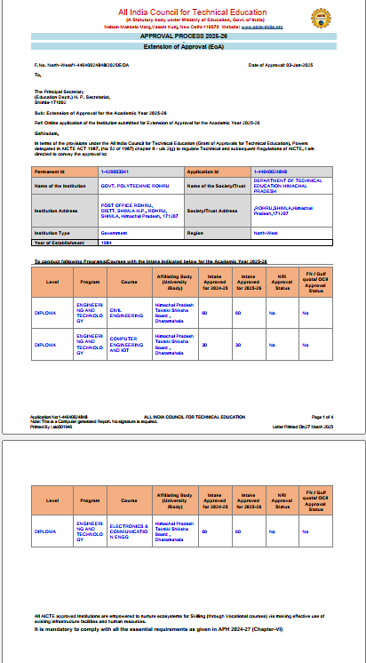

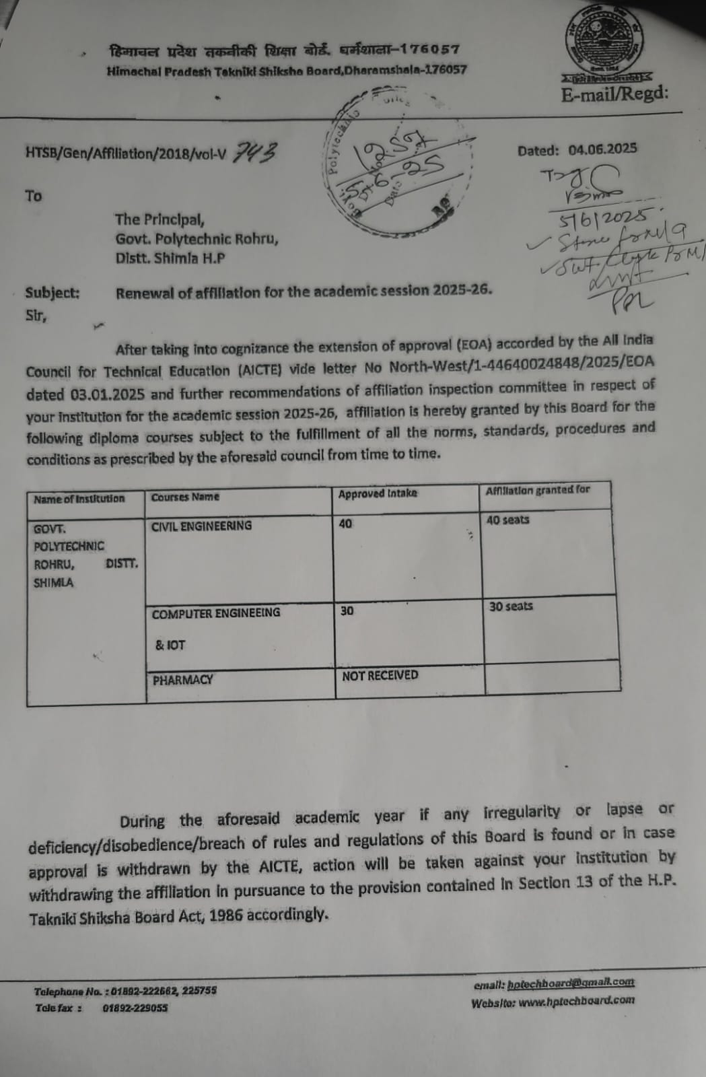
4. Details of Internship and Placement:- The details regarding passouts of diploma students & their placement is appended below:

Sr. No. | Name of the Cource | Sanctioned Intake ( 6th Sem ) |  | Total Nos. of Students Enroled in 6th Sem | Dropout |  |  | Total Nos. of Students Appeared in Exam of 6th Sem |  | Total Nos. of Students Passout ( All Clear in all Sem) |  | Placement
 |  |  |  |  |  |  |  |  |  |  |  | Govt. Sector* |  | Private Sector* |  |  |  | Opted Higher Studies*
1 | D.Electonics & Comm. Engg | 66 |  | 26 | NIL |  |  | 26 |  | 17 |  | Nil |  | 08 |  |  |  | 3
2 | D. Pharmacy | 40 |  | 36 | NIL |  |  | 36 |  | 27 |  | Under hospital Training
* List of the Companies & Organisation Attached in Annexure -1
List of the Govt. Organisation & Private Companies
Department of Electronics & Comm. Engg
Sr. No. | Name of the Organisation |  |  |  |  |  |  |  |  |  |  |  |  |  |  |  | No. of students Placed
1 | Gabriel India Pvt. Ltd Parvanoo HP |  |  |  |  |  |  |  |  |  |  |  |  |  |  |  | 02
2 | Plasser India Ltd. Faridabad Haryana |  |  |  |  |  |  |  |  |  |  |  |  |  |  |  | 03
3 | Jio Company Solan |  |  |  |  |  |  |  |  |  |  |  |  |  |  |  | 01
4 | Jio Company Rampur |  |  |  |  |  |  |  |  |  |  |  |  |  |  |  | 01
5 | Jio Company Chopal |  |  |  |  |  |  |  |  |  |  |  |  |  |  |  | 01
8 | Under Hospital training at various Govt. Hospital |  |  |  |  |  |  |  |  |  |  |  |  |  |  |  | 21

5. Fees with Complete Breakup and Details: The semester wise detail of fee structure as notified by Govt. Of H.P. is appended below:

Fee Structure for 1st & 3rd Semester (LEET) (For Newly Admitted Students) July-Dec

Sr. No. | Particulars | Boys | Girls | TFW | PWD
1 | Admission Fee | 250 | 250 | 250 | 0
2 | Tuition Fee | 1500 | 0 | 0 | 0
3 | Identity Card | 50 | 50 | 50 | 50
4 | Institutional Security | 1000 | 1000 | 1000 | 1000
5 | Library Security | 500 | 500 | 500 | 500
6 | Corpus Fund | 20 | 20 | 20 | 20
7 | Annual Festival/Cultural Charges | 200 | 200 | 200 | 200
8 | Magazine Fee | 100 | 100 | 100 | 100
9 | Premium for Group Insurance | 100 | 100 | 100 | 100
10 | Library Fee | 200 | 200 | 200 | 200
11 | Medical Fee | 100 | 100 | 100 | 100
12 | Examination Fee (Internal Exam) | 300 | 300 | 300 | 300
13 | Institute Development Fund | 1000 | 1000 | 1000 | 1000
14 | Computer Fee | 500 | 500 | 500 | 500
15 | Industrial Visit Charges | 150 | 150 | 150 | 150
 | Total | 5970 | 4470 | 4470 | 4220

Fee Structure for 2nd, 4th & 6th Semester (Jan-June)

Sr. No. | Particulars | Boys | Girls | TFW | PWD
1 | Tuition Fee | 1500 | 0 | 0 | 0
2 | Library Fee | 200 | 200 | 200 | 200
3 | Medical Fee | 100 | 100 | 100 | 100
4 | Examination Fee | 300 | 300 | 300 | 300
5 | Institute Development Fund | 1000 | 1000 | 1000 | 1000
6 | Computer Fee | 500 | 500 | 500 | 500
7 | Training & Placement Fee | 50 | 50 | 50 | 50
8 | Industrial visit Charges | 150 | 150 | 150 | 150
 | Total | 3800 | 2300 | 2300 | 2300

Continued ............

5. Fees with Complete Breakup and Details:


Fee Structure for 3rd & 5th Semester (July-Dec)

Sr. No. | Particulars | Boys | Girls | TFW | PWD
1 | Tuition Fee | 1500 | 0 | 0 | 0
2 | Corpus Fund | 20 | 20 | 20 | 20
3 | Annual Festival/Cultural Charges | 200 | 200 | 200 | 200
4 | Magazine Fee | 100 | 100 | 100 | 100
5 | Premium for Group Insurance | 115 | 115 | 115 | 115
6 | Library Fee | 200 | 200 | 200 | 200
7 | Medical Fee | 100 | 100 | 100 | 100
8 | Examination Fee (Internal Exam) | 300 | 300 | 300 | 300
9 | Institute Development Fund | 1000 | 1000 | 1000 | 1000
10 | Computer Fee | 500 | 500 | 500 | 500
11 | Training & Placement Fee | 50 | 50 | 50 | 50
12 | Industrial Visit Charges | 150 | 150 | 150 | 150
 | Total | 4235 | 2735 | 2735 | 2735

6. Extra Curricular Activities with Complete Details: The details of main

extra curricular activities is appended below:

- Campus Beautification :-

- Campus Beautification and development activities has been made under this various facilities like LED Street Lighting, CCTV have been installed in Administrative Block/Academic Block/Labs and Workshops.

- Tree plantation is carried out at regular intervals in the campus and outside the campus.

- Swachh Abhiyaan is being celebrated on weekly basis. Under this abhiyan, all the cannabis/opium plants have also been uprooted.

- Sports & Cultural Activities:- The Students participated in H.P. Inter Polytechnic Athletics Meet at GP Hamirpur(Boys) and GP(W) Kandaghat(Women) in the month of November 2024 and Cultural Meet held at G.P. Sundernagar in the Month of April 2025.

7. PTA with Address and Telephone Number of its Members:
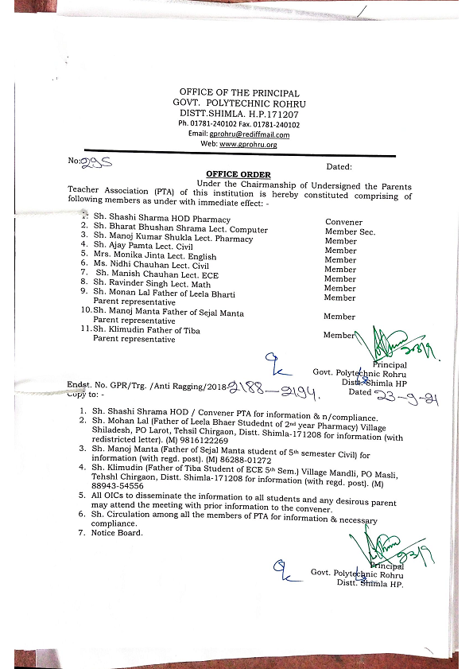

8. Transport Facilities with Details:
The transport facility is availed through HRTC and private vehicle as and when required.
9. Age of the Institute and its Achievements:

Govt. Polytechnic Rohru was established in the year 1985 with Electronics & Communication branch. However, in the year 1992 Diploma in Pharmacy also started. The Diploma in Electronics & Communication Engg. is approved by AICTE New Delhi and Diploma in Pharmacy is approved by PCI. One new Diploma in Computer Engineering and IoT has been started in the year 2023. This diploma is having AICTE approval.

At present the institution is providing the facilities of well equipped laboratories for conducting the practicals. The institute library has all latest magazines, periodicals, reference books for the students. The Institute also provide 24 hours Wi-Fi service in the campus. The hostel facility for both boys and girls students is also available.

Its Achievements:

- The campus has been made Wi-Fi and free access is available to students & staff of the institution.
- 4 KVA Solar power supply has also been installed in the institute for continuous & clean backup.
- The streetlights installed in the campus are time actuated and works automatically within set timings.
- Art of living program has been conducted in the Institution for the upliftment of the students.
- This institution has started New age Diploma in Computer Engineering and IoT. This is the first diploma in the state.

10. List of Alumni(s) along with Complete Addresses and Telephone Number: The details of the passouts students (Alumni‟s) in Electronics Engg. And Diploma Pharmacy is appended below:

Sr. No | Name of Candidate | Address | Contact No.
1 | Sanjeev Nariyal | Vill Dari, Dharamshala, Distt. Kangra | 9418019239
2 | Minakshi Thakur | VPO Salooni, Distt. Chamba H.P. | 9459042005
3 | Dr. Vivek Sharma | VPO Jubbal , Distt. Shimla H.P. | 9816532662
4 | Surender Dutta | VPO Rampur, Distt. Shimla H.P. | 9418500175
5 | Sujay Aggarwal | VPO Rohru, Distt Shimla H.P. | 9816712000

11. Scholarship to Students :-
